**Titanic: Machine Learning from Disaster**

**Final project report for CS498**

**Students:**

[AMIR ABED AL RA'OF MUSTAFA AL ZURAYQAT](https://elearning.just.edu.jo/user/view.php?id=13476&course=6151)

[MARWAN NASER AHMAD SHALAKHTI](https://elearning.just.edu.jo/user/view.php?id=14111&course=6151)

[ALA'A AMJAD RAFE' AL DAMEN](https://elearning.just.edu.jo/user/view.php?id=9804&course=6151)

* We started by reading the data from two files train_titanic.csv and test_titanic.csv.

* We created new column (SexNew) and filled it with (male, female and child) according to the age of each one …the following chart shows the number of male, female and child:

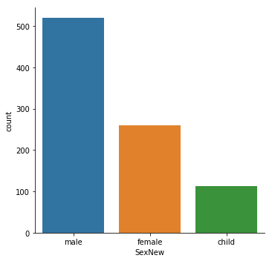

*We dropped (SEX) because we don’t need it anymore.

*We replaced the values in (SexNew) using the map function as follows:

(Male-0, Female-1, Child-2)

*The next chart shows the count of survived and not survived number according to the age.

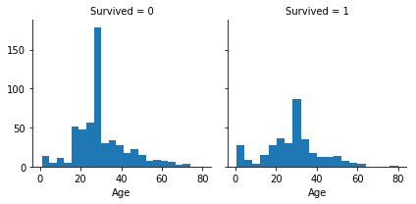

*The next chart shows the count of survived and not survived number according to the Pclass: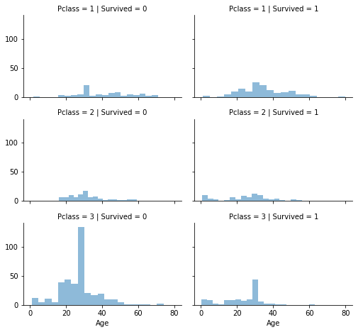

*We dropped ['Ticket', 'Cabin'] from the two files.

*We replaced the Name by title and filled it I with ['Lady', 'Countess','Capt', 'Col','Don', 'Dr', 'Major', 'Rev', 'Sir', 'Jonkheer', 'Dona'], and put it in title column as numbers using map fun.

*We dropped ['Name', 'PassengerId']...there is no need for them.

*We filled the null values in the [‘age’] column with the mean of age values.

Sample of output:

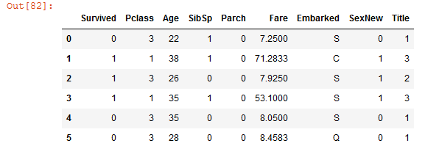

*The following chart shows the SexNew with Pclass.

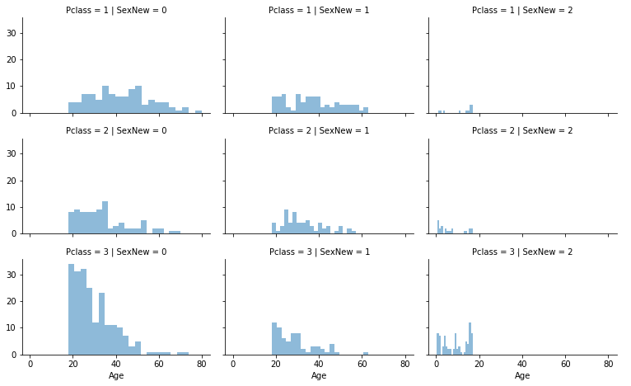

*We dropped ['Parch', 'SibSp', 'FamilySize'].

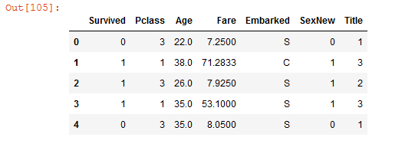

*In ['Embarked'] we used map fun for replacing the values with numbers as the following...

{'S': 0, 'C': 1, 'Q': 2}

*We filled the null values in [‘Fare’] with the mean value of [‘Fare’] values

*Sample of the data after mining and cleaning process:

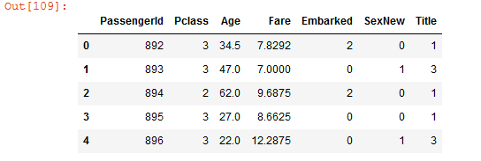

*After trying all algorithms this is the accuracy result:

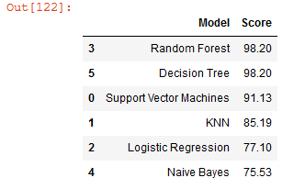

*The Random Forest and Decision Tree have the best result.